Time2Volunteer
for Employees
Guide contents:
1. Introduction
2. Benefits
3. How to register
4. Join your business’s group
5. Apply for a volunteer opportunity
6. Notifications
7. Support
1. Introduction
Time2Volunteer is an online volunteering platform for Hull and East Riding that advertises local volunteer opportunities.
It is an interactive place to see and share news stories, events, campaigns, case studies and celebrate volunteering. It also provides a free library of volunteer learning, training and useful links.
Time2Volunteer is managed by HEY Smile Foundation and Hull CVS. We are working with organisations across Hull and East Yorkshire to provide a more structured and accessible way to get involved with employee volunteer opportunities.

You may have received this practical guide from your workplace manager, to engage you with Time2Volunteer and employee volunteering.

In this guide, you will be introduced to the Time2Volunteer, find out how to register, search and apply for a volunteer opportunity.

When you register on Time2Volunteer, you will receive free access to Be Collective, a cloud-based volunteer management system.
This allows you to apply to volunteer opportunities, join volunteer groups that you may be interested in, manage your volunteering involvement online and log volunteered hours and achievements with a downloadable Volunteer Social CV.
If you need support with Time2Volunteer, Be Collective, or need this guide in an alternative format, please contact your workplace manager in the first instance.

2. Benefits
Volunteering is a great way to engage with and make a difference to your local community.
Businesses who have a corporate social responsibility (CSR) may offer several volunteering days to staff per year. Taking up this offer within work time can be an ideal way to get involved with volunteering.
Volunteering can improve your health and wellbeing and taking time to connect with other colleagues outside of work, while supporting local people and places, can have a big impact.
Within a business, employer supported volunteering can increase employee engagement and skills, improve job satisfaction, enhance team building and collaborations skills, boost productivity, brand reputation and public relations.
Time2Volunteer gives employees more individual control to find a volunteer opportunity suitable to them or their team. It also reduces staff time as employers won’t have to regularly ask volunteer organisations to source suitable opportunities.
Sharing your own employer supported volunteering experience with Time2Volunteer may also encourage other colleagues and businesses to become involved in volunteering, meaning a bigger difference for communities.

3. How to register
Click this web link:
Time2Volunteer
At the top right of the website, click on ‘Register as a volunteer’.
You will be asked for the following information:
Section: Profile Registration | Guidance
First Name | Your own personal name.
Last Name | Your own personal name.
Email address | Your own personal or work email.
Password | Must be 8 characters, include an upper/lower case, number and a special character.
Date of birth | This is asked to ensure age-appropriate opportunities.
I would like to receive communications from  Be Collective – Yes/No | Includes system/website updates. You can choose to opt in or out via  Profile > Settings > Notifications.

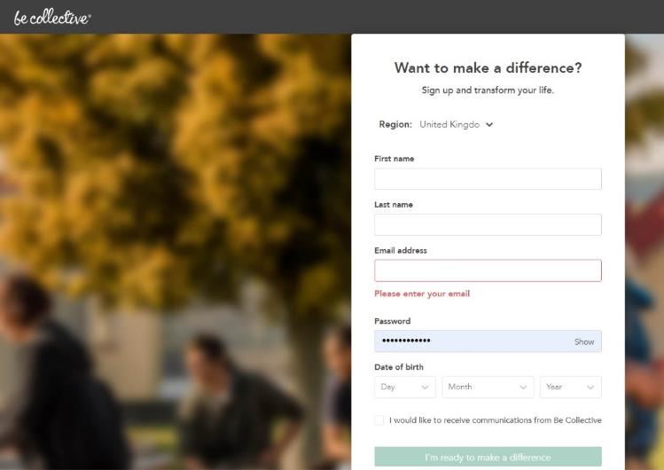

When prompted, accept the Terms & Conditions.
You will be asked to verify your email, so check your email and junk folder for a verification code email from Be Collective.
After entering the verification code, you will be prompted to complete the registration form to join the Time2Volunteer group.
We ask that you join the Time2Volunteer group so we can capture the number of volunteers and potential volunteers who are interested in volunteering in the region.
You will be asked for the following information:
Section: Group application | Guidance
First Name | This will be prefilled from previous entry.
Last Name | This will be prefilled from previous entry.
Email address | This will be prefilled from previous entry.
Contact number | This is asked in case you apply for an opportunity within the group.
Age | This will be prefilled from previous entry.
Suburb/Town/City | Start typing and select from the drop-down menu. This is asked for reporting purposes.
Gender | This is asked for reporting purposes.
Emergency contact name | This is asked in case you apply for an opportunity within the group.
Emergency contact number | This is asked in case you apply for an opportunity within the group.
Occupation (optional) | This is asked for reporting purposes.

Choose ‘Volunteer’ as the ‘Member type’. You will be redirected to your profile dashboard.

4. Join your business’s group
Use the search bar at the top of the website to find and select your business’s group ‘[manager to insert group name or web link to the group here]’.
Or, if your manager has already invited you to join the group via email, click ‘Accept invitation’.
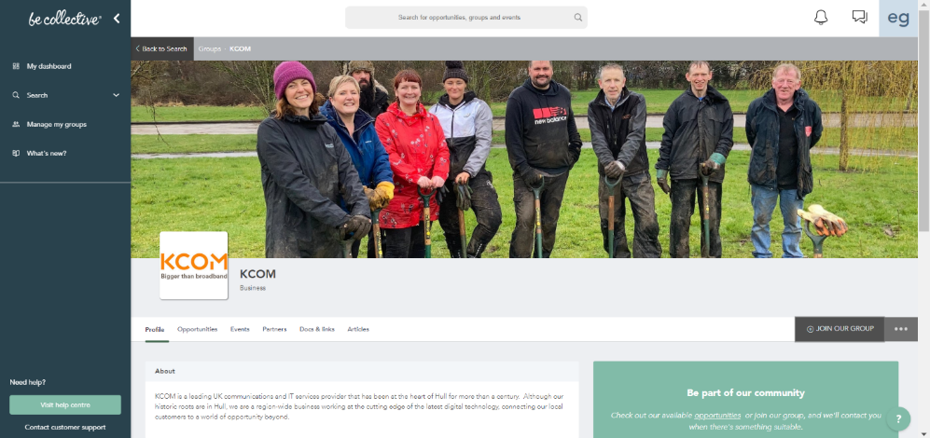
We ask that you join your business’s group so they can capture the number of colleagues who are interested in or actively volunteering and are able to directly contact you through the system.

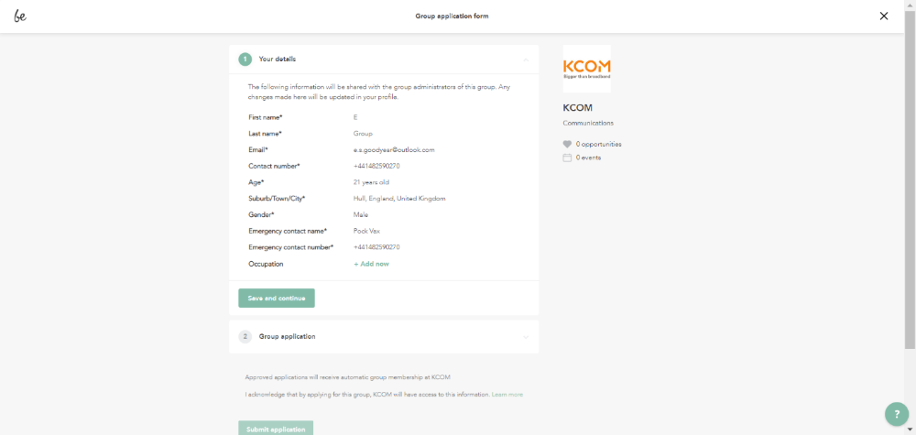
Click ‘Join our group’. You will be prompted to complete a short group application form like this:
Choose ‘Staff’ as the ‘Member type’. You will be redirected to your profile dashboard.
5. Apply for a volunteer opportunity
You can search for and apply to volunteer opportunities on the Time2Volunteer website.
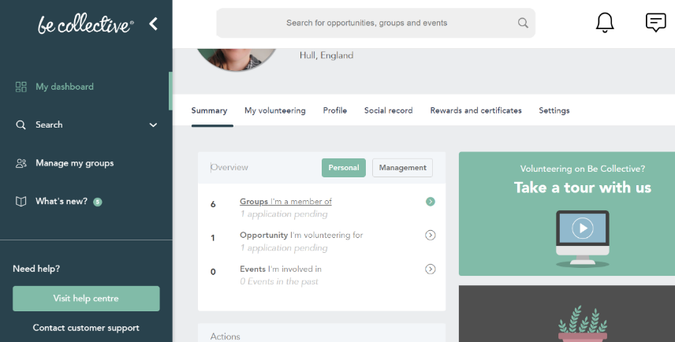
Or, while you’re logged in to Be Collective, from your profile’s dashboard, in the ‘Summary’ tab, you will see groups that you’re a member of.
Select the Time2Volunteer group and you will be taken to the group’s dashboard.
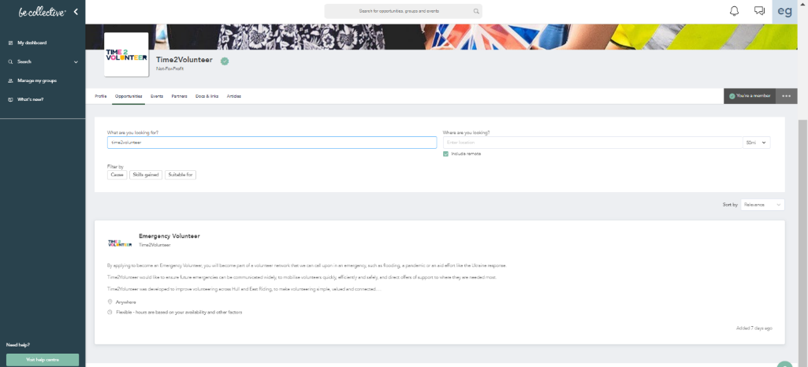
Click ‘Opportunities’ tab to browse volunteer opportunities.
When you have found a suitable volunteer opportunity, please follow your internal business process or forward on the details to your manager.
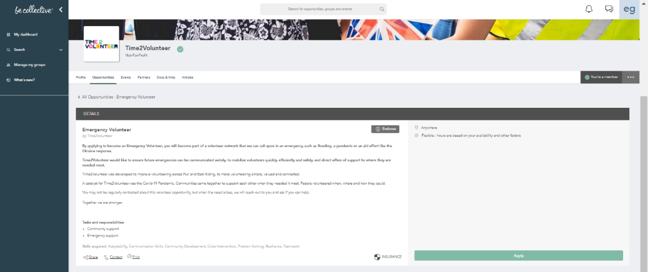
When you have internal approval to apply for the volunteer opportunity, select it and click ‘Apply’.

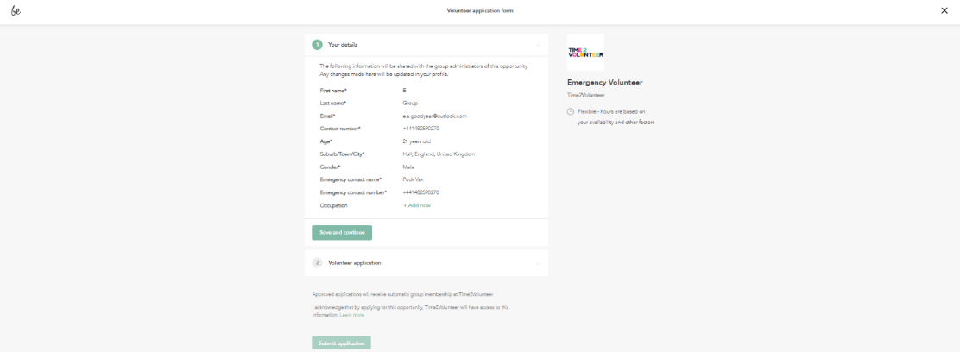
You will be prompted to complete a short volunteer application form:
This is where an organisation can ask specific questions to potential volunteers.
If the volunteer opportunity is specifically for employee volunteers, this may include additional fields such as: ‘Job title’ or ‘Company’ or ‘Applying as an individual or team’.
The volunteer application will go to the group recruiting for the opportunity.
Please advise your manager of your application and any future responses or actions.

6. Notifications
Unless you change your notification preferences, you will be notified of any activity via email and within the Be Collective website under the notifications bell icon (top right of the website when logged in).
Notifications may include a response to a Volunteer or Group application, updates from a Group or Opportunity or a direct message to you.

7. Support
If you need any support in using Time2Volunteer or Be Collective, please contact your workplace manager in the first instance. Happy volunteering!

