Employee Volunteering
For Organisations
Guide contents:
1. Introduction
2. Benefits
3. Create an employee volunteer opportunity
4. Accept an employee application
5. What a business needs
6. What a volunteer organisation needs
7. Think outside the box
8. Support
1. Introduction
Time2Volunteer is managed by HEY Smile Foundation and Hull CVS. We are working with organisations across Hull and East Yorkshire to provide a more structured and accessible way to get involved with employee volunteer opportunities.

This practical guide is to support a volunteering organisation to engage with Time2Volunteer and employee volunteering, when employees participate in company organised activities that contribute positively to communities.

In this guide, you will find out how to post specific employee volunteer opportunities on Time2Volunteer. We will also provide information on what a business needs in place to engage their staff in volunteering, and what a volunteering organisation should have.

HEY Smile Foundation and Hull CVS regularly work with businesses to source and recommend volunteer opportunities for their staff to take part in, both individuals and teams.
This takes time and knowledge, and often we can only refer them on to volunteer organisations whom we know and who have worked with businesses in the past.
As Time2Volunteer is an online volunteering platform for Hull and East Riding that advertises local volunteer opportunities, we want that to include employee specific opportunities.
Creating a directory of sorts to be able to give to businesses, means that they will easily and quickly be able to see different types of volunteer opportunities and organisations that their staff can engage with.
A separate guide ‘Getting started with Time2Volunteer for Volunteer Managers’ and the videos T2V - New organisation registration - YouTube and T2V Creating a Volunteer Opportunity - YouTube are available to explain how to first get registered on Time2Volunteer and how to post opportunities.

If you need support with Time2Volunteer, Be Collective, or need this guide in an alternative format, please contact HEY Smile Foundation or Hull CVS.

2. Benefits
Businesses are increasingly keen to contribute to their local community and this often involves supporting charitable or community-based projects. Corporate Social Responsibility (CSR), where businesses consider their social, environmental, and other responsibilities, is now an important part of many companies’ activities. It brings benefits such as recruiting and retaining motivated staff, improving brand awareness, and helping to increase sales or profits.
These businesses may offer several volunteering days to staff per year. For them, especially large businesses with lots of staff, this means finding suitable new and different volunteer opportunities on a regular basis.
By engaging with employee volunteering, your organisation will be able to advertise bigger volunteer projects that might be suitable for a large team of people to take part in, allowing you to get more done in a shorter time frame.
You will generally attract a wider volunteer demographic. Employee volunteering brings in people new to volunteering, more diverse, younger, or skilled people.
Working with businesses means publicity. Businesses like to promote what they’ve been doing to help local communities, by engaging on social media and in the press.
Once you have engaged with employee volunteers and businesses, and they have a positive experience, they are more likely to want to work with you again in the future.
This may be coming back to you for another volunteer opportunity, or perhaps a single employee might approach you to volunteer in their own time.
They are likely to share successful volunteer opportunities with other departments and employer managers.
Developing a successful relationship with a business can mean ongoing sponsorship or support. It can bring new prospects to a volunteer organisation.
Sharing your own employee volunteering experience with Time2Volunteer, may also encourage other businesses to become involved in volunteering, meaning a bigger difference for your organisation and local communities.

3. Create an employee volunteer opportunity
Below we will discuss how to create a specific employee volunteer opportunity by using a few functions that can make an opportunity more relevant and accessible to employee volunteers.
If you find that you don’t have access to some of these functions, please let us know as your account may need to be upgraded for free from the standard plan.
Keyword title
The easiest way to make your employee volunteer opportunity to stand out is to include the word ‘corporate’, ‘employee’ or ‘team’ within the title. When an employee volunteer or manager uses a keyword like this in the search bar, your opportunity will be displayed.
Opportunity suitable for
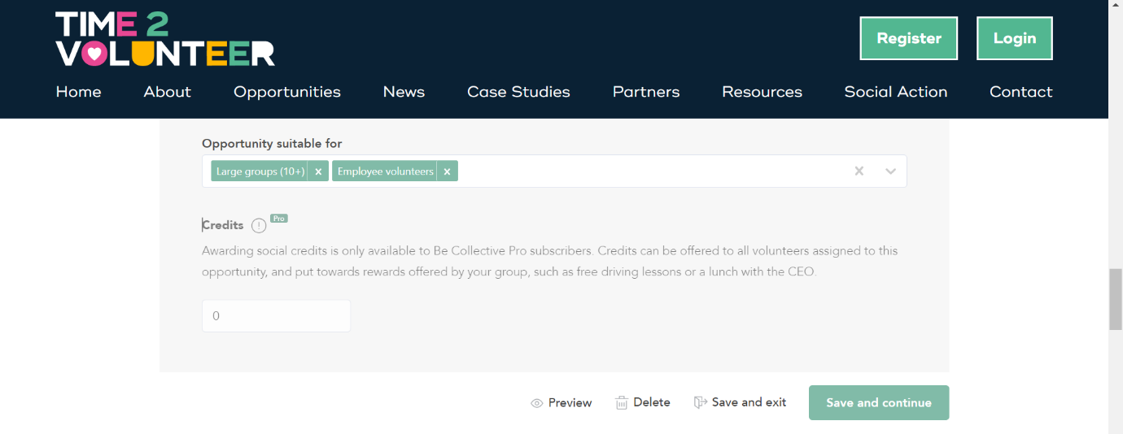
This section allows you to tick that your opportunity is suitable for large groups and/or employee volunteers.
If your opportunity is suitable for even a smaller group of 3-5 people, we would still recommend ticking the large groups option.
When an employee volunteer or manager filters the opportunities with one of these options, your opportunity will be displayed.

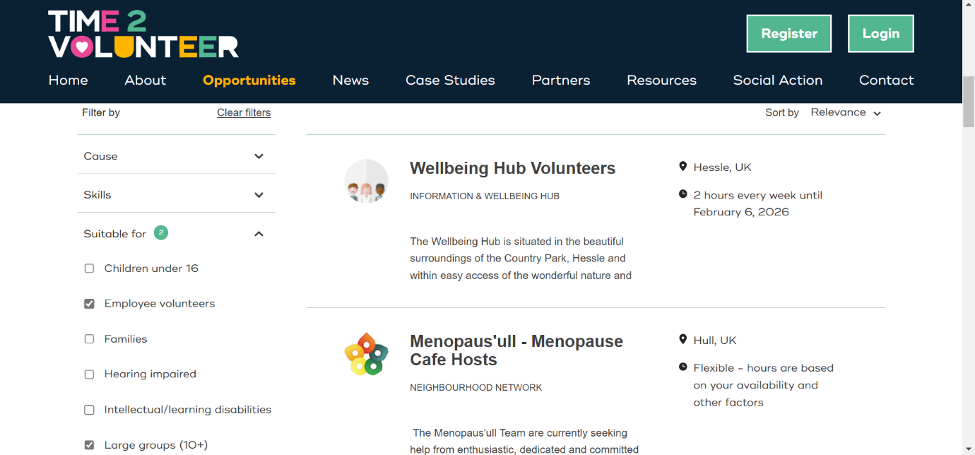
Flexible vs shifts
If an employee volunteer or team can join your opportunity at a time that can be ad hoc, use the ‘Flexible’ option. Ticking that the hours can be based on the availability of the volunteer/s shows that you can be adaptable and liase with the corporate manager around how many hours their staff can give.
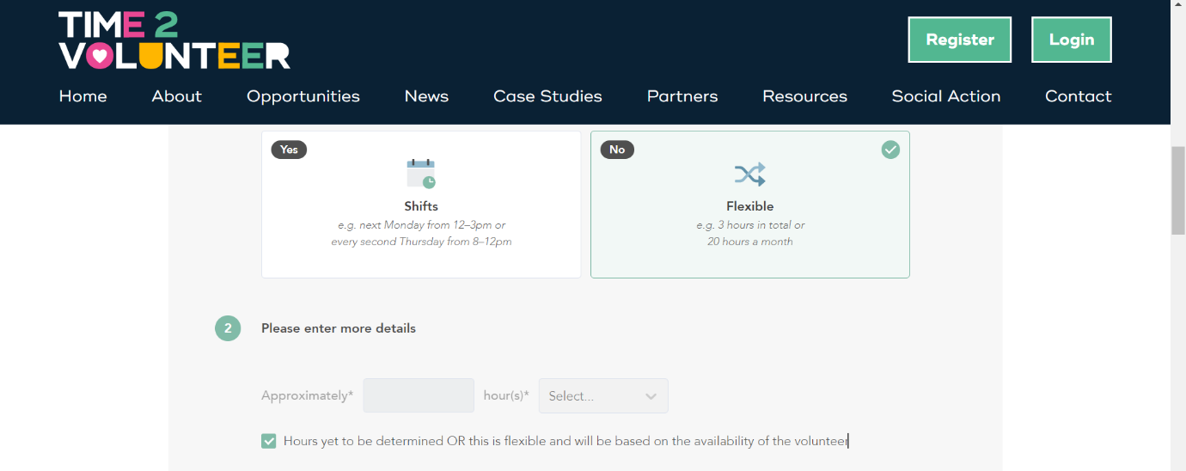
If, however, your opportunity must be on a set date or time, then use the ‘Shifts’ option. If a business has enough advance notice, they can plan volunteer days to align with when you need support.

Customise application form
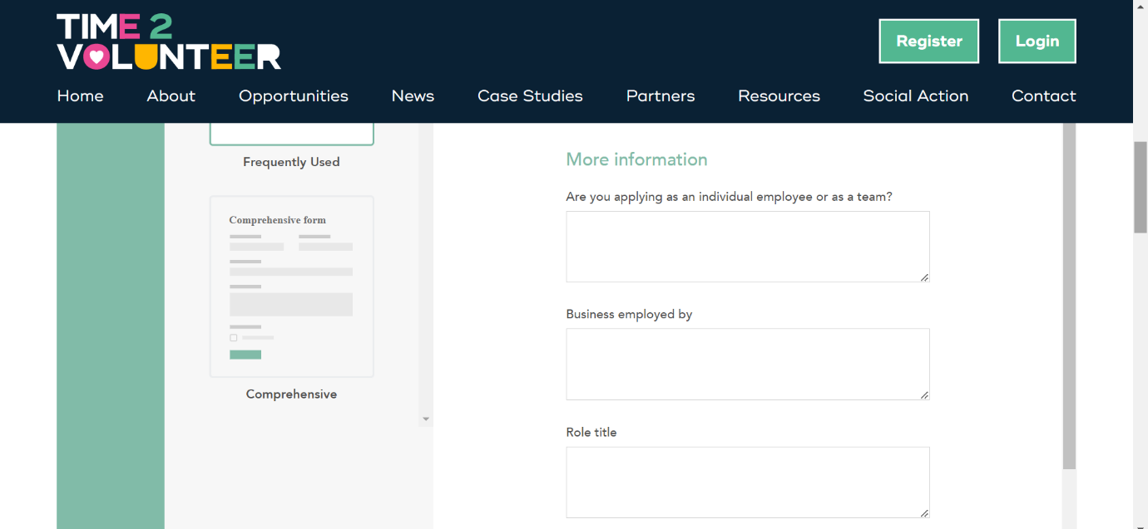
You can customise the application form to include employee specific questions like:

This may be useful to be certain which business they are applying from and to find out contact details for their corporate manager.
Volunteer brief
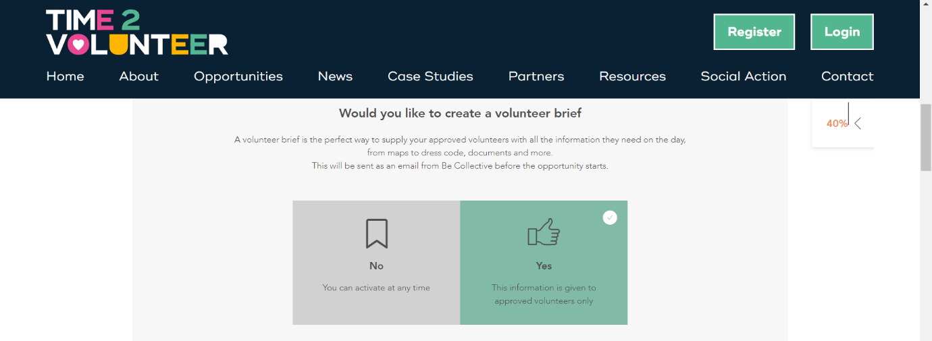
Preparing a corporate specific volunteer opportunity means that you can make use of the volunteer brief section.
Here, you can upload a risk assessment or write about safety information, as well as including a reminder about where and when the opportunity is and thanking volunteers for their involvement.
Everything in a volunteer brief gets emailed to approved volunteers before their opportunity starts. It is a great way to save time and ensure that all people participating have seen important information before the day.
Share opportunity
If you have previously requested a partnership with a business group on Time2Volunteer, when creating a volunteer opportunity, you will be able to tick a box to share it with the manager.
If they feel it would be suitable for their staff, they may endorse it or share it with them.
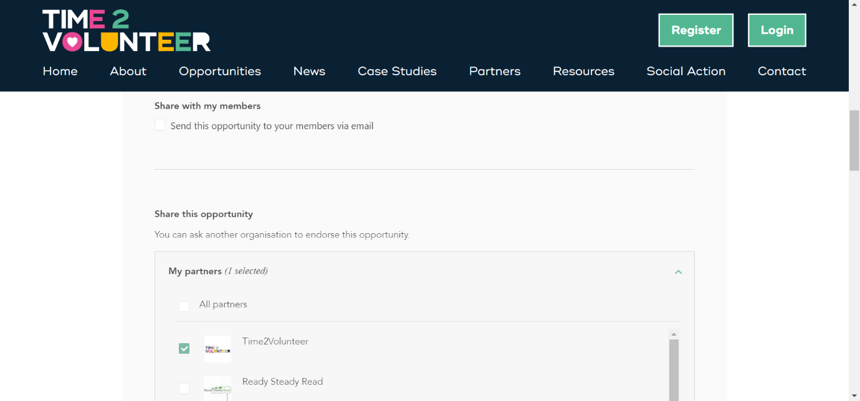
Likewise, if any employee volunteers join your organisation’s group, then you can also tick a box to email the opportunity direct to them.

4. Accept an employee application
When an employee volunteer has found a suitable volunteer opportunity, they should follow their internal business process or forward on the details to their manager for approval.
They may then apply directly to your opportunity, or their manager may liaise with you for further details.
To capture the most accurate data for each party involved, for reporting purposes, we recommend that each volunteer should individually apply to the volunteer opportunity that they want to be a part of.
However, if this is not possible, their manager may apply to your volunteer opportunity on behalf of an individual or team.
You should review, approve and manage the application in the usual way.

5. What a business needs
There are several things that a business needs in place before engaging their staff in employee volunteering.
The first is to have appropriate employee liability insurance cover that includes staff working off site during working hours.
They may also need a risk assessment that considers the risks associated with staff working off site, including lone working.
Your organisation should request a copy of both documents.

6. What a volunteer organisation needs
There are several things that businesses will expect from volunteer organisations before engaging their staff in employee volunteering with them.
Your organisation needs to have public liability insurance that includes volunteers. You should provide a copy of this to the manager.
You should also conduct your own risk assessment that considers the risks associated with employee volunteers working with you, specific to the volunteer day and tasks. You should provide a copy of this to the manager. Please see the Volunteer Risk Assessment Template here for further guidance.
It is recommended that when advertising a volunteer opportunity, you should provide information on how accessible the opportunity is. Make sure the manager knows about anything that might prevent a volunteer from taking part. Think about wheelchair access, is there a time limit to the shift or regular breaks if the task is strenuous, do you need a language interpreter etc?
You should provide an induction to employee volunteers, either beforehand or as a team briefing on the day of volunteering. This should include an introduction to staff and other volunteers, guidance on the volunteer tasks, sufficient safety advice relevant to the tasks, timings of the day/shift and who to ask for support.
Refreshments and toilets should be made available to all volunteers.
It is good practise to ask the manager if you can take photographs or gather quotes from volunteers while they are volunteering, for the purpose of partnership promotion. Take along a photography consent form and ask if they can sign it.
Most businesses will be happy to be featured on an organisation’s website or social media, so tag their account if you can.
Taking a before and after photo of a volunteer project can make for good case study material and Time2Volunteer would be happy to share this.

7. Think outside the box
A lot of current employee volunteer opportunities are based around a large team day project, like landscaping and gardening at an allotment.
HEY Smile Foundation’s Hull Vault moved home from Armadillo Storage to Umber Creative in February 2023. Corporate partner Balfour Beatty kindly transported all equipment and items across town to their new home, then painted the space, put shelving racks up and moved everything in.
Just in this one example, you can see how two businesses have provided long term storage support to an organisation, and another has used volunteer hours and staff in moving goods and renovating the space.
To read some case studies about corporate volunteers, click here: Case Studies | Time2Volunteer
A lot of businesses say that while they enjoy getting involved with tangible and manual volunteer opportunities like this, it would be great to see a more diverse range of opportunities available.
Consider these ways that employee volunteers can get involved:
- Sponsored challenge like a fun run or mountain climb – volunteer time spent doing this is their volunteering hours/days, and the funds they raise go to your organisation
- Business product sale, bake sale or dress down day, where proceeds go to your organisation
- Support an event as a regular volunteer would or by running a workshop around how volunteering can increase employability skills and experience
- Review an organisation’s social media or website and implement a plan to improve it – then ongoing digital marketing support
- Case study or promotional writing – learn about an organisation, write up about it or gather photos and promote it
- Promotional leaflet design, printing and distribution
- Give administrative expertise like IT, organisational, accountancy and policy support
- Mentor an organisation’s staff, volunteers or beneficiaries
- Organise donation collections or care packages for beneficiaries
Please note, you may need a Commercial Participation Agreement (CPA) to engage with some fundraising ideas.
Tips
- Approach a business and ask what types of volunteering their staff engage with best
- Don’t presume that employees want to volunteer in a similar field to their business – many report that they enjoy doing something completely different and learning new skills
- Reach out to businesses to remind them that volunteering is a good way to drive team morale and wellbeing
- Consider remote volunteering opportunities that work from home staff can engage with
- Employee volunteers can give your organisation a bank of ambassadors who can spread the word about the amazing work you do

8. Support
If you need support with Time2Volunteer, Be Collective, or need this guide in an alternative format, please contact HEY Smile Foundation or Hull CVS.

