Time2Volunteer
for Employers
Guide contents:
1. Introduction
2. Benefits
3. Register your business
4. Invite staff to join your business group
5. Search for a volunteer opportunity
6. Apply for a volunteer opportunity
7. Notifications
8. What your business needs
9. What a volunteer organisation needs
10. Support
1. Introduction
Time2Volunteer is an online volunteering platform for Hull and East Riding that advertises local volunteer opportunities.
It is an interactive place to see and share news stories, events, campaigns, case studies and celebrate volunteering. It also provides a free library of volunteer learning, training and useful links.
Time2Volunteer is managed by HEY Smile Foundation and Hull CVS. We are working with organisations across Hull and East Riding to provide a more structured and accessible way to get involved with employee volunteer opportunities.

This practical guide is to support an employer to engage with Time2Volunteer and volunteering in the workplace.

In this guide, you will be introduced to Time2Volunteer, find out how to register your business and how staff search and apply for a volunteer opportunity. We will also provide information on what a business needs in place to engage their staff in volunteering, and what a volunteer organisation should have.

When you register on Time2Volunteer, you will receive free access to Be Collective, a cloud-based volunteer management system.
From an employee’s point of view, this allows them to apply to volunteer opportunities, join volunteer groups that they may be interested in, manage their volunteering involvement online and log volunteered hours and achievements with a downloadable Volunteer Social CV.
From an employer’s point of view, this allows you to request your staff to join your registered business group so that you can see who is registered and engaging with volunteering, and directly message them via the group or individual chat function.
A separate guide ‘Time2Volunteer for Employee Volunteers’ is available to give to your staff and explains how they should register as individuals.

If you need support with Time2Volunteer, Be Collective, or need this guide in an alternative format, please contact HEY Smile Foundation or Hull CVS.

2. Benefits
Volunteering is a great way to engage with and make a difference to your local community.
Businesses who have a corporate social responsibility (CSR) may offer several volunteering days to staff per year. Staff taking up this offer within work time can be an ideal way to get involved with volunteering.
Volunteering can improve people’s health and wellbeing and taking time to connect with other colleagues outside of work, while supporting local people and places, can have a big impact, both internally and externally.
Within a business, employer supported volunteering can increase employee engagement and skills, improve job satisfaction, enhance team building and collaborations skills, boost productivity, brand reputation and public relations.
Time2Volunteer gives employees more individual control to find a volunteer opportunity suitable to them or their team. It also reduces an employer’s time, as you won’t have to regularly ask volunteer organisations to source suitable opportunities.
Sharing your own employer supported volunteering experience with Time2Volunteer may also encourage other colleagues and businesses to become involved in volunteering, meaning a bigger difference for communities.

3. Register your business
The following guidance explains how you register your business to engage with staff who access employee volunteering.

(If you would prefer a video guide, please click here: T2V - New organisation registration - YouTube)
Click this web link:
Time2Volunteer
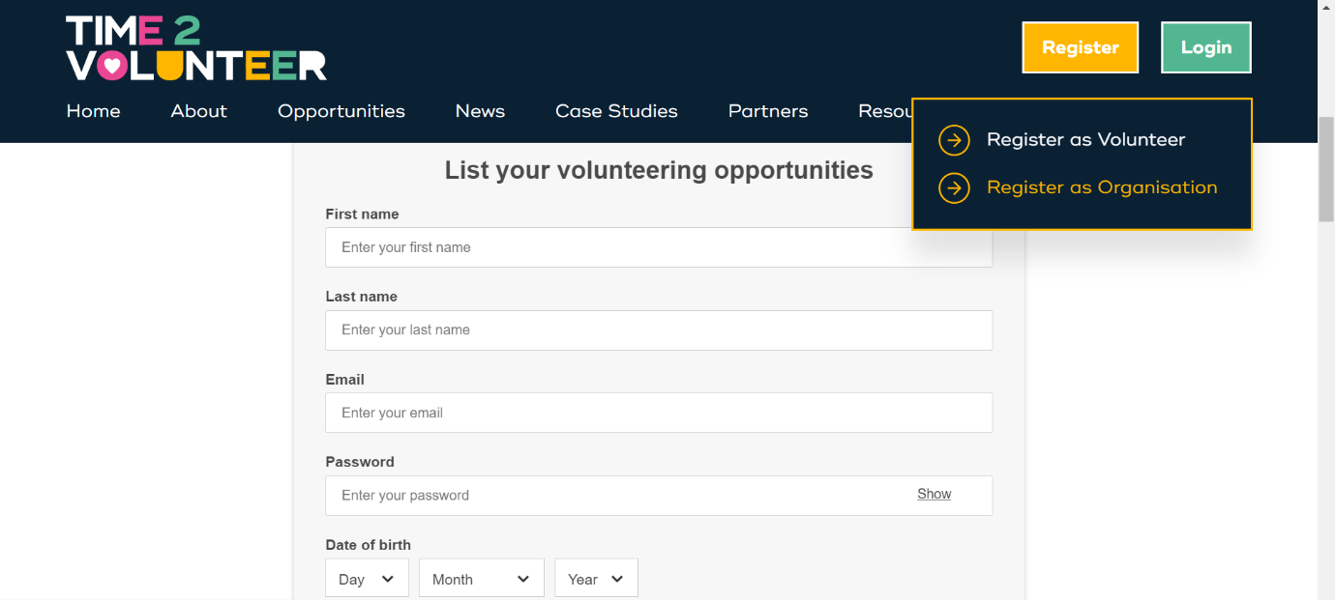
At the top right of the website, click on ‘Register as an organisation.
You will be asked for the following information:
Section: Personal registration | Guidance
First Name | Your own personal name.
Last Name | Your own personal name.
Email | Your own work email address.  (Your individual profile can be used to search and apply for volunteer opportunities that you are interested in for yourself, separate to the groups you manage.)
Password | Must be 8 characters, include upper/lower, number and a special character.
Date of birth | This is asked to ensure age-appropriate opportunities and to distinguish between youth and adult volunteering for reports.
I would like to receive communications from Be Collective – Yes/No | Includes system/website updates. You can choose to opt in or out via Profile > Settings > Notifications.
Section: About your Group | Guidance
Name of group | The name of your business.
Select group type  - Business | Group details can be amended later via Manage my group > Edit > General.
Select industry type
Description | Here are some things to think about when writing your group description:  What does your business do? What is your community focus? How do you involve staff as volunteers?
Click ‘Next’. You will be asked to verify your email, so check your email and junk folder for a verification code email from Be Collective.
When you have entered the code, you will be asked for the following information:
Section: Finalise your Group | Guidance
Group Logo | Drag and drop or click to select and upload logo. If you don’t have one to hand, you can add one in later.
Location | Start to type postcode, town or city and select location from drop down list.
Insurance
- We have insurance
- We don’t have insurance
- We are auspice by another organisation
If choosing ‘We have insurance’:  - Public Liability insurer name  - Policy number  - Insured value  - Expiry  - Employer’s liability  - Policy number  - Insured value  - Expiry  If choosing ‘We are auspiced by another organisation’:  - Organisation name | If you don’t have the information to hand, you can choose ‘We don’t have insurance’ then amend later via Manage my group > Edit > Insurance.
Click ‘Finalise group’.
You will be asked to create a volunteer opportunity, but this is only relevant to community groups and charities. Please scroll down and click ‘Delete’ then ‘Confirm’ which will delete this draft opportunity.

4. Invite staff join your business group
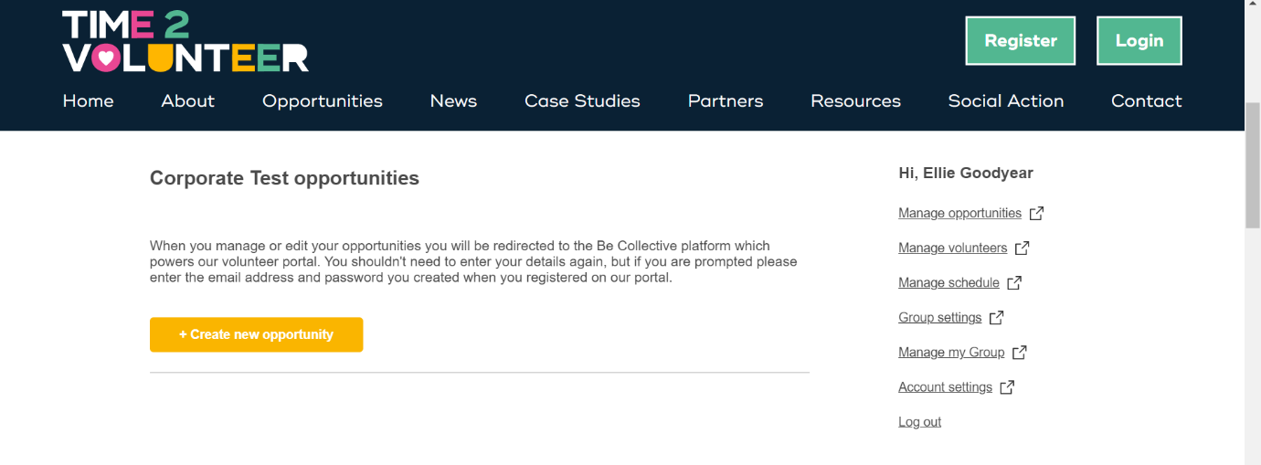
When you are logged in on the Time2Volunteer website, you will see this view:
On the right hand side, click ‘Manage my Group’.
This will redirect you to the Be Collective website, where you have more functionality.
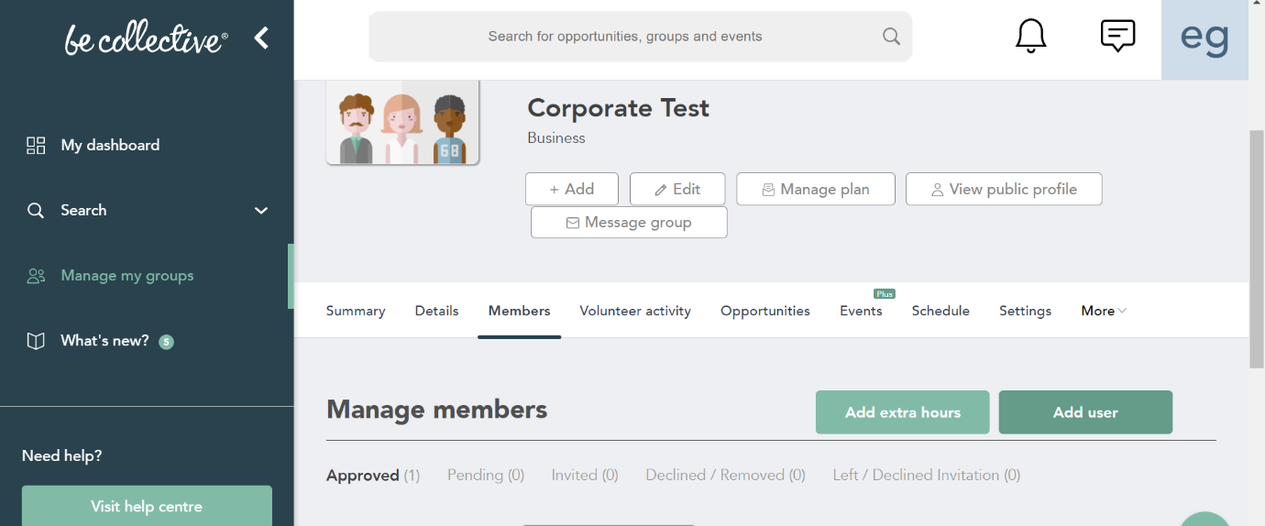
Click on the ‘Members’ tab.
Click ‘Add user’. Here you can add colleagues using their first and last name and email address.
They will get an email notification to say that they have been invited to join your group.
In the guide ‘Time2Volunteer for Employees’, we explain how to search for and join their business group, so you may find you do not need to invite all colleagues.

5. Search for a volunteer opportunity
Time2Volunteer is a great way to give employees more individual control to find a volunteer opportunity suitable to them or their team.
If you or they are looking for a volunteer opportunity, please click here:
Time2Volunteer | Volunteering Opportunities
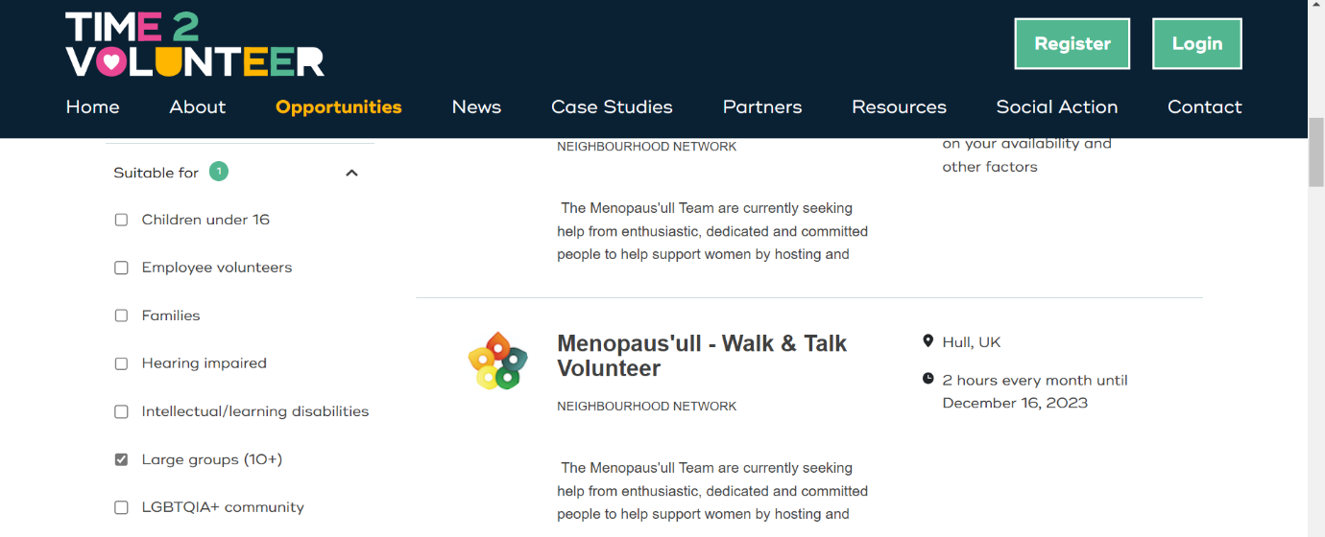
On the filter function, you can choose ‘Suitable for large groups’ and/or ‘Employee volunteers’.

We are encouraging volunteer organisations to advertise specific employee opportunities, and to make use of these filter options so that you can easily find them.
When a colleague has found a suitable volunteer opportunity, they should follow your internal business process or forward on the details (website link) to their manager for approval.
Likewise, if you also find a suitable opportunity, please forward on the details (website link) to staff.

6. Apply for a volunteer opportunity
To capture the most accurate data for each party, for reporting purposes, we recommend that each colleague individually apply to the volunteer opportunity that they want to be a part of, and keep you informed.
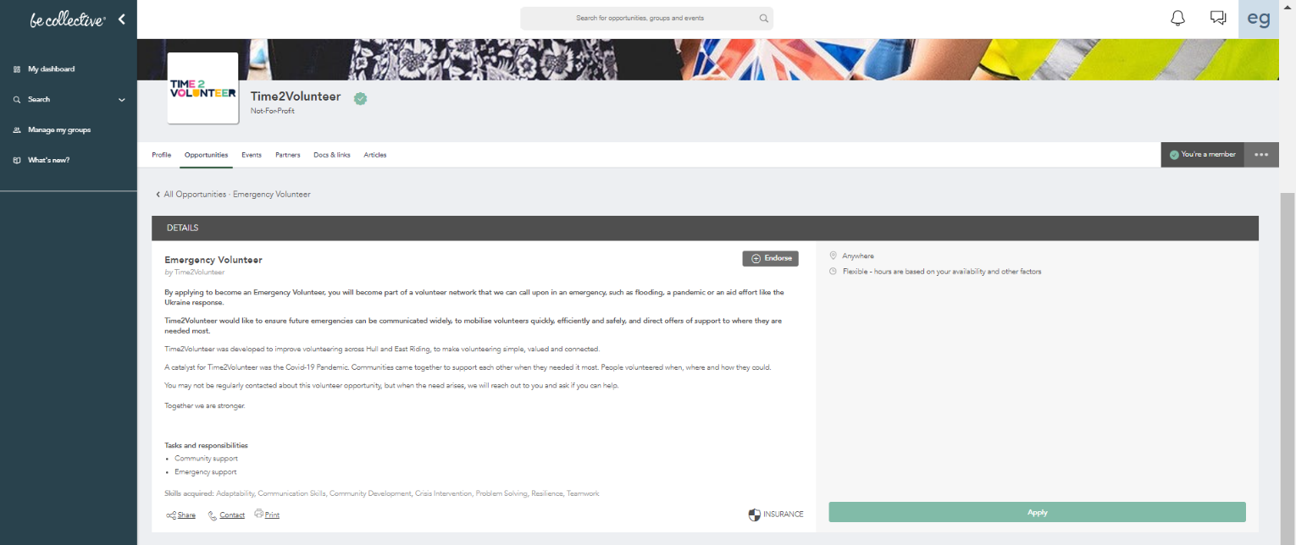
However, if this is not possible and you need to apply to a volunteer opportunity on behalf of your team or an individual, select it and click ‘Apply’.
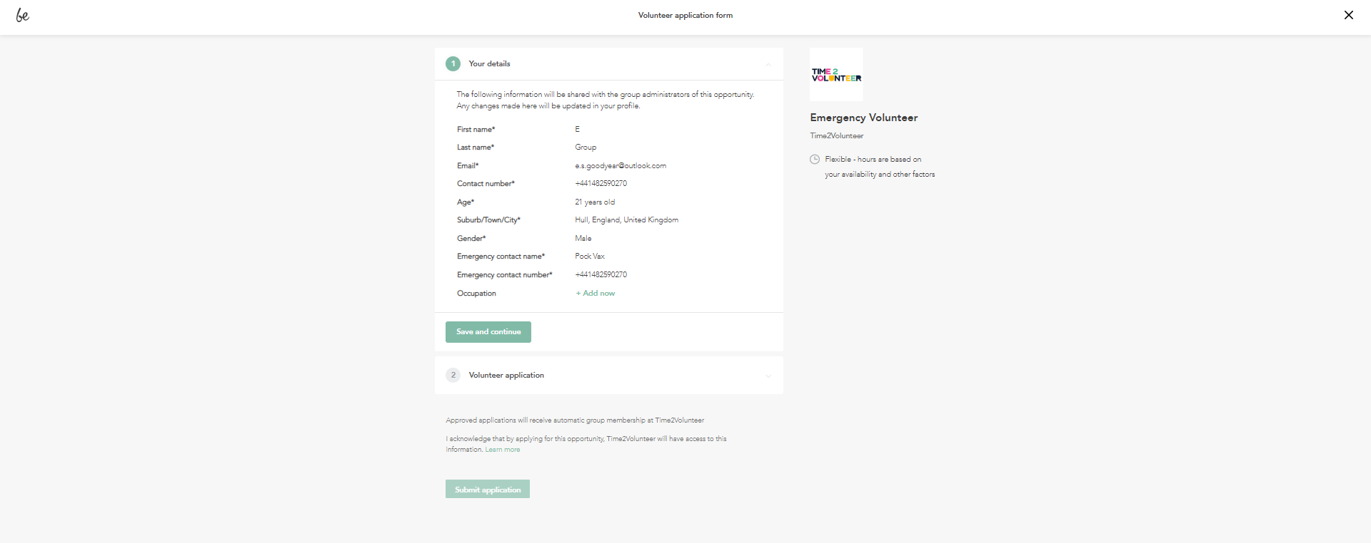
You must be a member of the group that is posting the opportunity before you can apply.
You will then be prompted to complete a short volunteer application form:

This is where an organisation can ask specific questions to potential volunteers.
If the volunteer opportunity is specifically for employee volunteers, this may include additional fields such as: ‘Job title’ or ‘Company’ or ‘Applying as an individual or team’.
Once submitted, the volunteer application form will go to the volunteer organisation who is posting the opportunity and who should contact you.

7. Notifications
Unless you change your notification preferences, you will be notified of any activity via email and within the Be Collective website under the notifications bell icon (top right of the website when logged in).
Notifications may include a response to a Volunteer or Group application, updates from a Group or Opportunity or a direct message to you.

8. What your business needs
There are several things that your business needs in place before engaging staff in employee volunteering.
The first is to have appropriate employee liability insurance cover that includes staff working off site during shifts or working hours.
You may also need a risk assessment that considers the risks associated with staff working off site, including lone working. Please see the Volunteer Risk Assessment Template here for further guidance.

9. What a volunteer organisation needs
There are several things that you should expect from volunteer organisations before engaging your colleagues in employee volunteering with them.
The volunteer organisation or charity would need to have public liability insurance that includes volunteers. You can request to see a copy of this.
They should also conduct a risk assessment that considers the risks associated with your colleagues volunteering with them. You can request to see a copy of this.
The volunteer organisation or charity should provide an induction to you and your colleagues, which may happen beforehand or as a team briefing on the day of volunteering. This should include an introduction to staff and other volunteers, guidance on the volunteer tasks, sufficient safety advice relevant to the tasks, timings of the day/shift and who to ask for support.
Refreshments and toilets should also be provided by the volunteer organisation or charity.

10. Support
If you need support with Time2Volunteer, Be Collective, or need this guide in an alternative format, please contact HEY Smile Foundation or Hull CVS.

